Etpyrafen

HPLC method

CIPAC Small Scale Collaborative Trial

5141/m

By Ms Wang Haixia
Shenyang Research Institute of Chemical Industry Co., Ltd
Pesticides Test Laboratory
No.8, Shenliao Dong Road, Tiexi District, Shenyang City,
P. R. of China

Presented at the CIPAC meeting in Panama

June, 2018

ETPYRAFEN

ISO common name Etpyrafen

Chemical name (Z)-2-(4-tert-butylphenyl)-2-cyano-1-(1-ethyl-3-methylpyrazol-5-yl)vinyl 2,2-dimethylpropionate (IUPAC)
(1Z)-2-cyano-2-[4-(1,1-dimethylethyl)phenyl]-1-(1-ethyl-3-methyl-1H-pyrazol-5-yl)ethenyl 2,2-dimethylpropanoate (CA, 1253429-01-4)

Empirical formula C₂₄H₃₁N₃O₂

RMM 393.53

m.p. 97.2°C~98.6℃

v.p. 8.9×10⁻⁸ Pa at 20°C

Solubility In water 0.0890 mg/L at 20°C; In methanol 114~133 g/L, hexane 29~33 g/L. In acetone, dichloromethane, xylene, ethyl acetate >250 g/L

Stability Stable for 14 d at 54 ℃

Description The pure material is a white, odourless solid

Formulation Suspension concentrates (SC)

ETPYRAFEN technical

1 Sampling. Take at least 100 g.

2. Identity test

2.1 HPLC. Use the reversed phase HPLC method below. The relative retention time of the Etpyrafen peak in the sample solution should not deviate by more than 1.5% from that of the calibration solution.

2.2 Infrared. Prepare potassium bromide discs for the technical sample and Etpyrafen reference substance. A typical potassium bromide disc should contain a sample prepared in the 0.15-0.35% by weight range. Scan the discs from 4000 to 600 cm⁻¹. The spectrum of the sample should not differ significantly from that of the reference substance.

3 Etpyrafen

OUTLINE OF METHOD Etpyrafen is determined by reversed phase high performance liquid chromatography using UV detection at 230 nm and external standardisation.

REAGENTS

Acetonitrile HPLC grade
Phosphoric acid Analytically pure
Water HPLC grade
0.05% Phosphoric acid solution Dissolve 0.5 ml Phosphoric acid into 1000 ml water

Etpyrafen reference standard of known content. Store refrigerated.

Calibration solutions. Weigh in duplicate about 40 mg (to the nearest 0.1 mg) of Etpyrafen reference standard (s mg) into separate brown volumetric flasks (100 ml). Add acetonitrile (about 80 ml) and place the flask in an ultrasonic bath for 3 min. Allow to cool to ambient temperature and fill to the mark with acetonitrile. Mix thoroughly. (calibration solutions C_{A} and C_{B}).

APPARATUS

High performance liquid chromatograph equipped with a detector suitable for operation at 230 nm (UV-detection) and an injection system capable of injecting 5 µl.

Liquid chromatographic column stainless steel, 150 x 4.6 mm (i.d.), Agilent ZORBAX SB C₁₈, 5μm, or equivalent with the same selectivity.

Electronic integrator or data system

Ultrasonic bath

PROCEDURE

- Chromatographic conditions (typical)

Column temperature 30°C
Flow rate 1.0 ml/min
Detector wavelength 230 nm
Injection volume 5 µl
Mobile phase acetonitrile - phosphoric acid solution, 800 + 200 (v/v)
Retention time etpyrafen approximately 8.4 min

- Equilibration of the system. Pump sufficient mobile phase through the column to equilibrate the system. Inject 5 µl portion of calibration solution C_{A} until the response obtained from two consecutive injections deviate by less than 1.5%. Then inject 5 µl portion of calibration solution C_{B}. The response factor for this solution should not deviate by more than 1.5% from that for calibration solution C_{A}, otherwise prepare new calibration solutions.

- Preparation of Etpyrafen TC sample. Prepare sample solutions in duplicate for each sample. Weigh (to the nearest 0.1 mg) sufficient sample (w mg) to contain about 40 mg of Etpyrafen into a brown volumetric flask (100 ml). Add acetonitrile (about 80 ml) and place the flask in an ultrasonic bath for 3 min. Allow to cool to ambient temperature and fill to the mark with acetonitrile. Mix thoroughly. (sample solutions S₁ and S₂).

- Determination. Inject in duplicate 5 μl portions of each sample solution bracketing them by injections of the calibration solutions as follows: calibration solution C_{A}, sample solution S₁, sample solution S₁, calibration solution C_{B}, sample solution S₂, sample solution S₂, calibration solution C_{A}, and so on. Measure the relevant peak areas. Average the values of the duplicate sample injections. Calculate the mean values of the response factors of the calibration solution bracketing two sample solutions and use this value to calculate the Etpyrafen content of the bracketed samples.

- Calculation. Determine the peak area of Etpyrafen and calculate the mean value of response factors from the calibration solutions bracketing the injections of the sample solutions and use this value for calculating the Etpyrafen content of the bracketed sample solutions. The Etpyrafen content is the mean value of two sample solutions.

$$f_{i}=\frac{s×P}{H_{s}}$$

Etpyrafen content $=\frac{f×H_{w}}{w}$ g/kg
where:
f_{i} = individual response factor
f = mean response factor
H_{s} = peak area of Etpyrafen in the calibration solution
H_{w} = peak area of Etpyrafen in the sample solution
s = mass of Etpyrafen reference standard in the calibration solution (mg)
w = mass of sample taken (mg)
P = purity of Etpyrafen reference standard (g/kg)

ETPYRAFEN suspension concentrates

/SC/M/-

1 Sampling. Take at least 600 ml.

2. Identity test

2.1 HPLC. As for Etpyrafen technical /TC/M/2.1

2.2 HPLC-MS

PROCEDURE

- Preparation of sample. Homogenise the sample by vigorous shaking. Weigh (to the nearest 0.1 mg) sufficient sample to contain about 40 mg of Etpyrafen into a brown volumetric flask (100 ml). Add water (about 5 ml) to emulsify the sample, then add acetonitrile (about 80 ml) and place the flask in an ultrasonic bath for 3 min. Allow to cool to ambient temperature and fill to the mark with acetonitrile. Mix thoroughly. Filter through a 0.45 µm PTFE filter prior to injection.

- Chromatographic conditions (typical)

Liquid chromatographic column stainless steel, 250 x 4.6 mm (i.d.), Agilent Shim-pack GIST C₁₈, 5 µm, or equivalent with the same selectivity.
Column temperature 30°C
Flow rate 1.2 ml/min
Injection volume 20 µl
Mobile phase Methanol - 0.1% Formic acid solution, 900 + 100 (v/v)
Detector MS
Ionisation mode +ESI
Full scan mode 100 - 1000 m/z
Total run time 20 min
Retention time Etpyrafen approximately 6.4 min

The spectrum produced from the sample should not differ significantly from that of the standard.

3 Etpyrafen

As for Etpyrafen technical /TC/M/3 except

- Preparation of sample. Homogenise the sample by vigorous shaking. Prepare sample solutions in duplicate for each sample. Weigh (to the nearest 0.1 mg) sufficient sample (w mg) to contain about 40 mg of Etpyrafen (s mg) into a brown volumetric flask (100 ml). Add water (about 5 ml) to emulsify the sample, then add acetonitrile (about 80 ml) and place the flask in an ultrasonic bath for 3 min. Allow to cool to ambient temperature and fill to the mark with acetonitrile. Mix thoroughly. Filter an aliquot of each prepared solution through a 0.45 µm PTFE filter prior to analysis (sample solutions S₁ and S₂).

4 Suspensibility

REAGENTS AND APPARATUS. As for Etpyrafen technical /TC/M/- and MT 184.

PROCEDURE

- Preparation of suspension and determination of sedimentation. MT184.

- Determination of Etpyrafen in the bottom 25 ml of suspension. After removal of the top 225 ml of suspension transfer the remaining 25 ml to a brown volumetric flask (100 ml) with acetonitrile (about 60 ml). Place the flask in an ultrasonic bath for 3 min. Allow to cool to ambient temperature and fill to the mark with acetonitrile. Mix thoroughly. Filter through a 0.45 µm filter prior to analysis. Determine the mass of Etpyrafen (Q g) by Etpyrafen/TC/M/3.

- Calculation

Suspensibility$=\frac{\text{111}(c−Q)}{c}$%
where:
c = mass of Etpyrafen in the sample taken for the preparation of the suspension (g)
Q = mass of Etpyrafen in the bottom 25 ml of suspension (g)

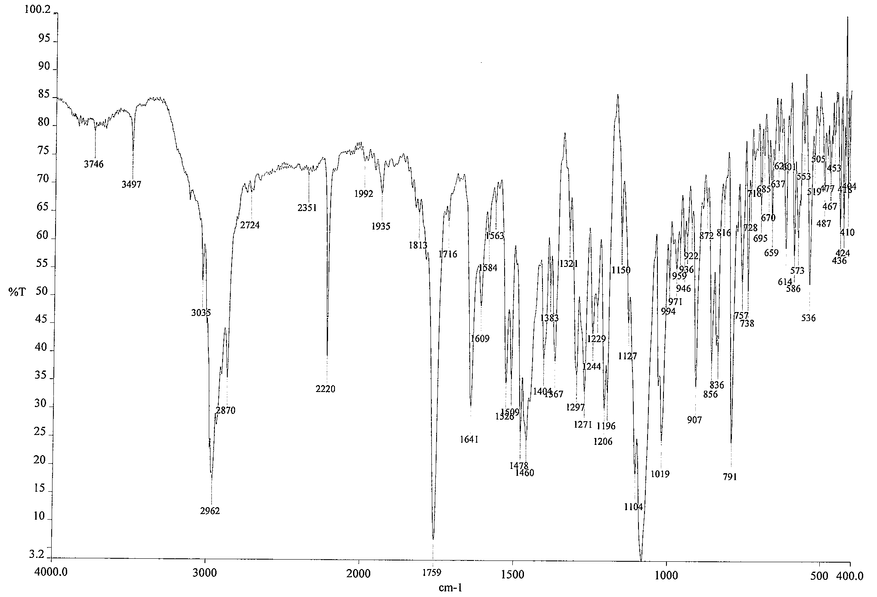
Fig.1 Infrared spectrum of Etpyrafen

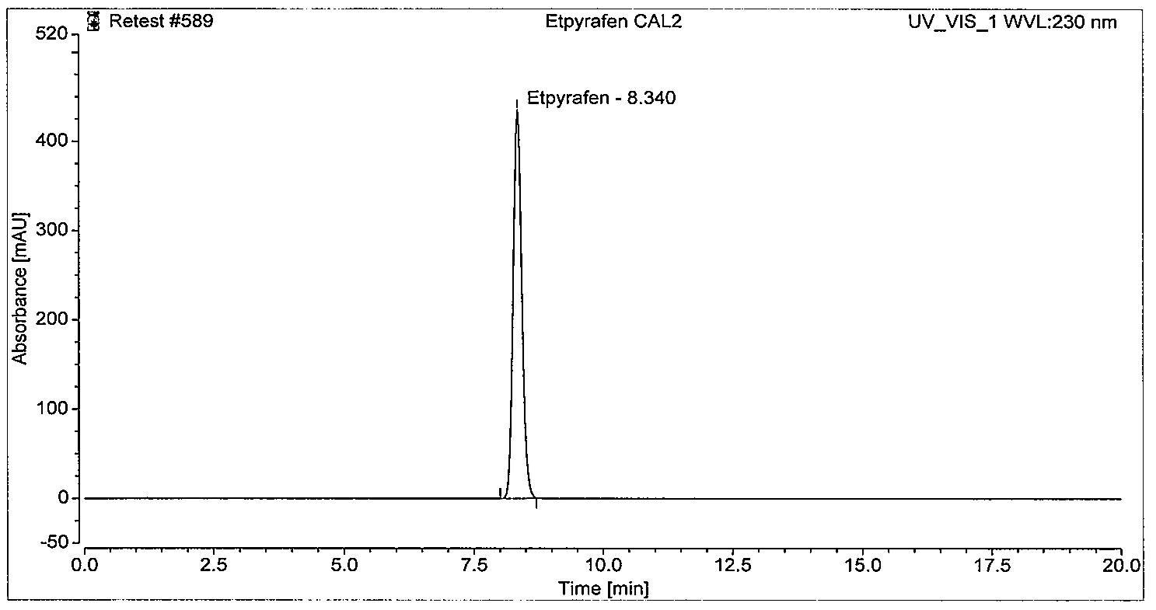
Fig.2 HPLC chromatogram of Etpyrafen standard

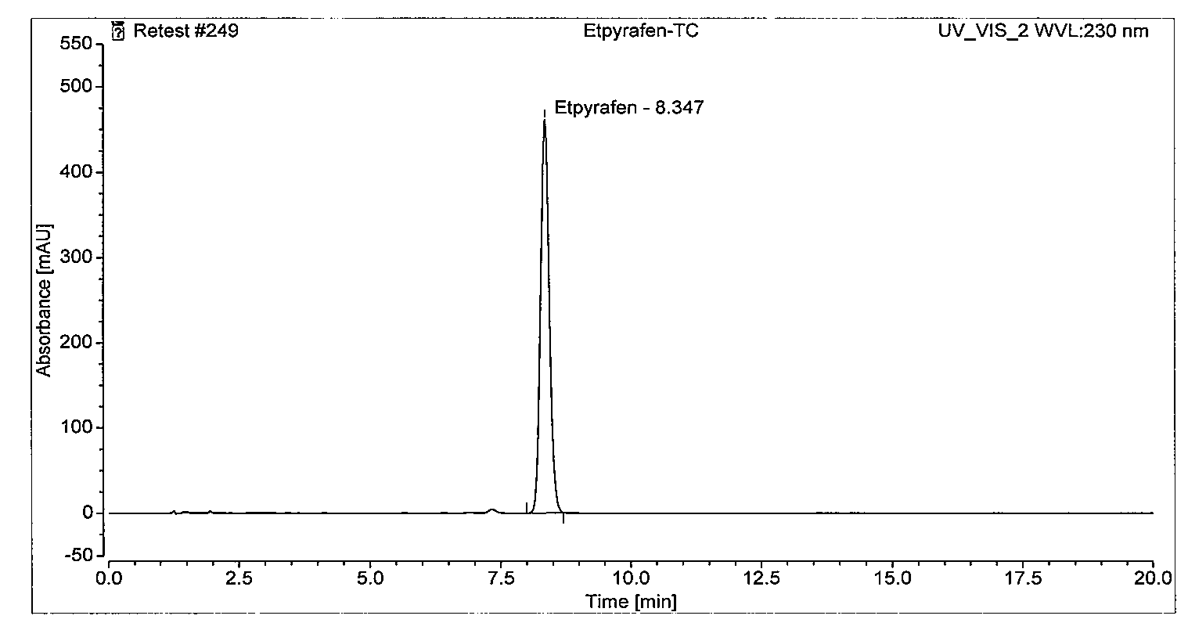
Fig.3 HPLC chromatogram of Etpyrafen TC

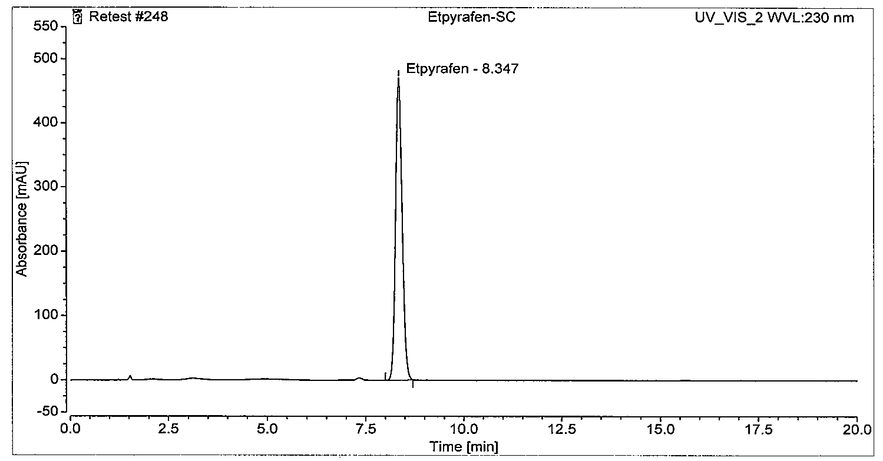
Fig.4 HPLC chromatogram of Etpyrafen SC

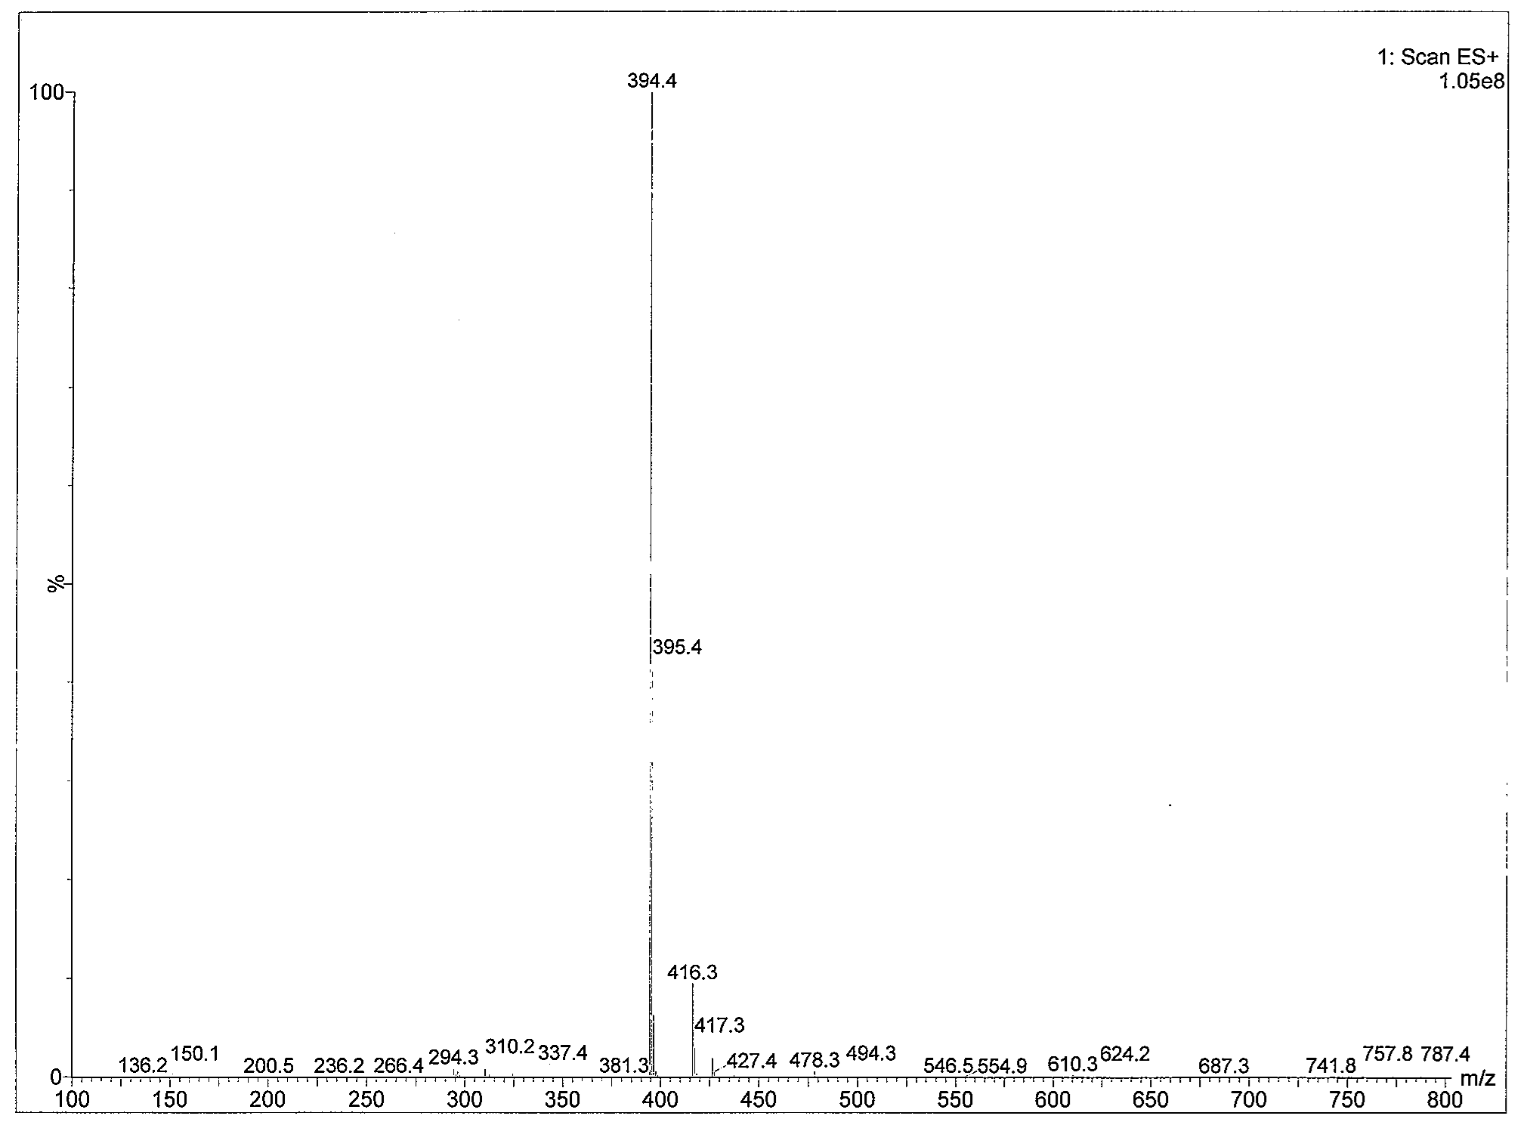
Fig.5 HPLC-MS spectrum of Etpyrafen standard

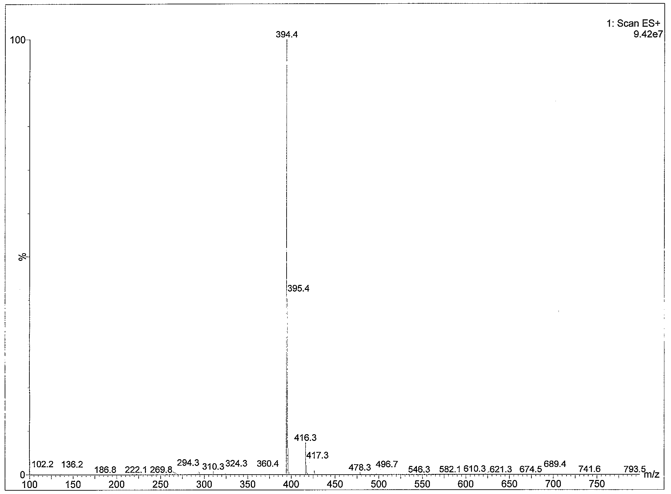
Fig.6 HPLC-MS spectrum of Etpyrafen SC

